Shapes by User Input – Ayush Gattani

import turtle

t=turtle.Turtle()

shape=str(input('Enter Your Shape:'))

if shape.lower() == 'triangle':

a=int(input('Enter Length:'))

t.forward(a)

t.left(120)

t.forward(a)

t.left(120)

t.forward(a)

elif shape.lower()=='rectangle':

r=int(input('Enter Length: '))

b=int(input('Enter Breadth: '))

t.forward(r)

t.left(90)

t.forward(b)

t.left(90)

t.forward(r)

t.left(90)

t.forward(b)

elif shape.lower()=='circle':

c=int(input('Enter Radius:'))

t.circle(c)

elif shape.lower()=='square':

s=int(input('Enter Side:'))

t.forward(s)

t.left(90)

t.forward(s)

t.left(90)

t.forward(s)

t.left(90)

t.forward(s)

Rectangle

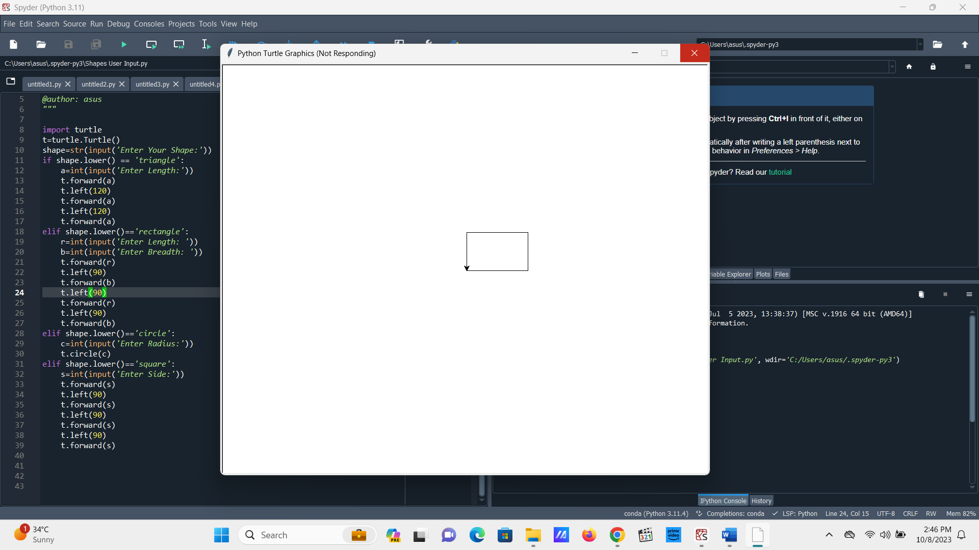

Square

Triangle

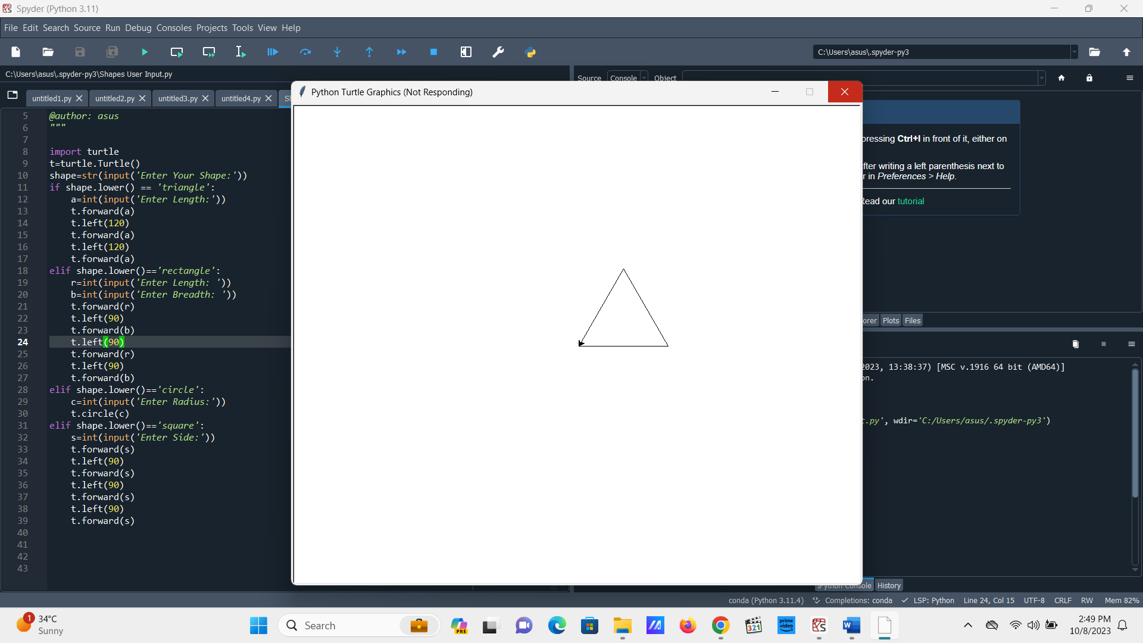

Circle

